**CS105.3**

**Database Management Systems**

**Tutorial 1 – Introduction to DBMS -I**

**Questions:**

1. Discuss the difference between data and information. Provide examples from the real world for each term.
2. What are the two data-gathering methods? Give examples for each method.
3. Using examples from the real world discuss how we interact with data in our day-to-day life.

*****

Comments for the tutors:

* Discuss the primary data vs secondary data, and quantitative data vs qualitative data.

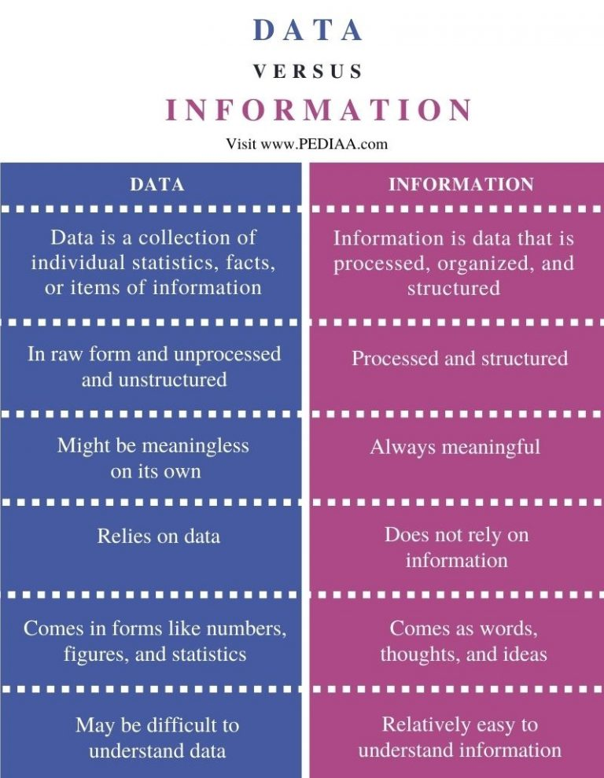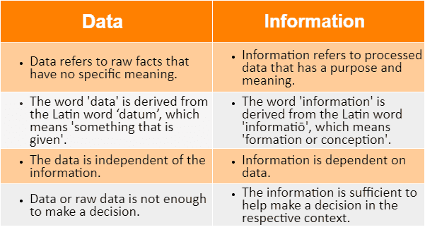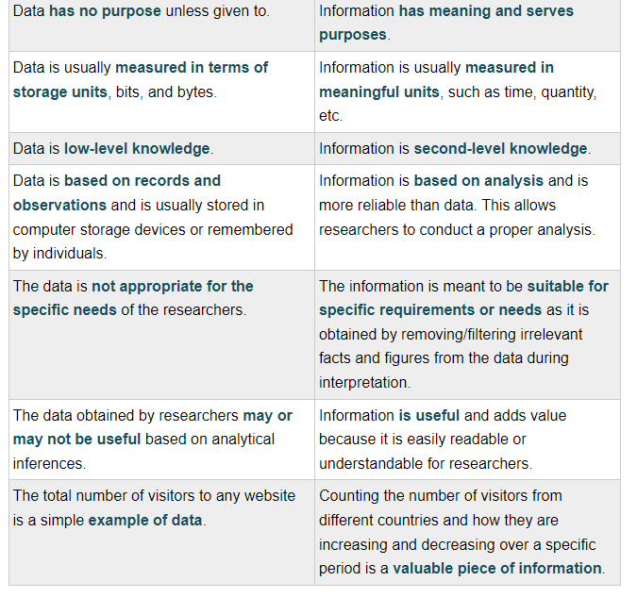

**Primary data refers to the first hand data gathered by the researcher himself.** **Secondary data means data collected by someone else earlier**. Surveys, observations, experiments, questionnaire, personal interview, etc.Aug 19, 2022

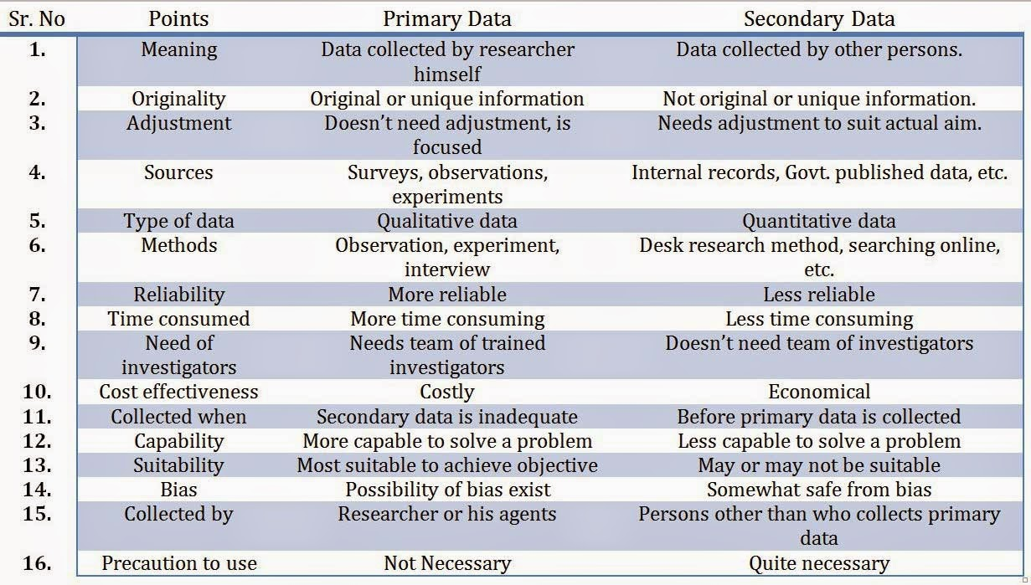

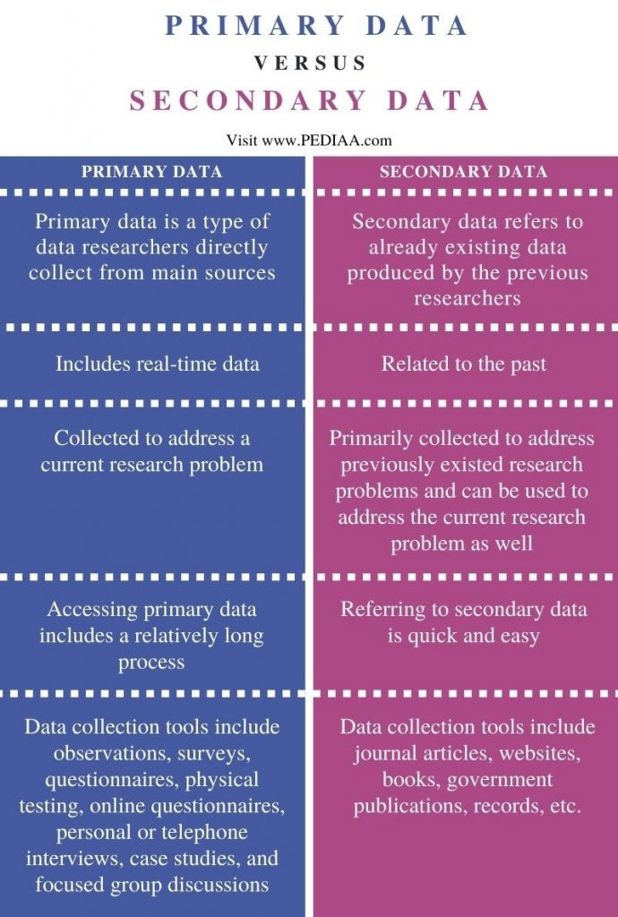

Examples of data in everyday life

**10 Database Examples You Regularly Use**

* On-Demand Online Video Streaming. ...
* Social Gaming. ...
* Personal Cloud Storage. ...
* Sports. ...
* Finances. ...
* Government Organizations. ...
* Social Media. ...
* eCommerce.